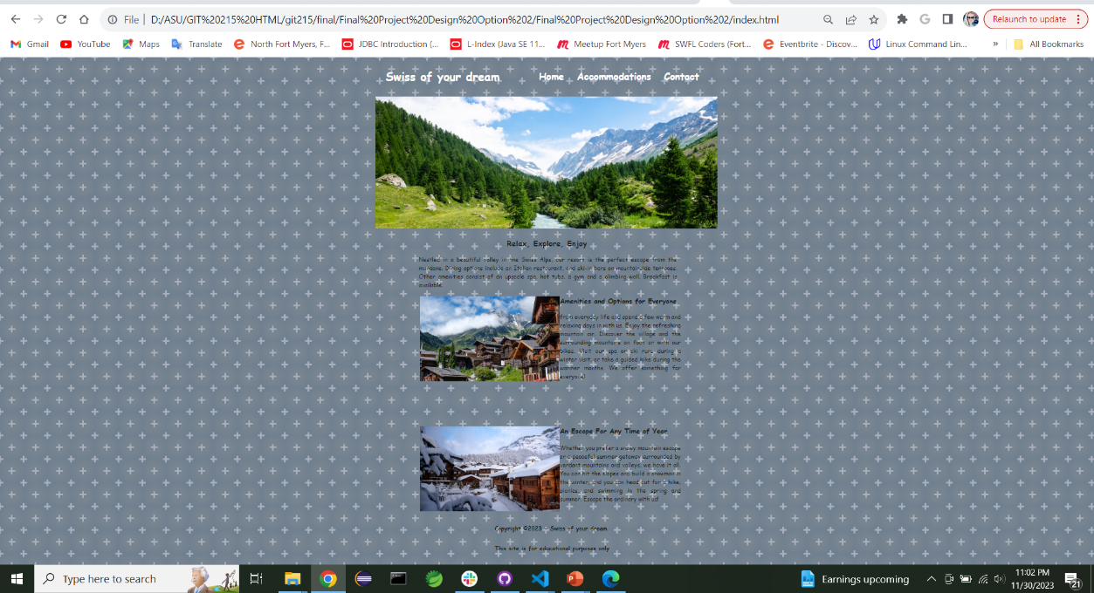Chrome

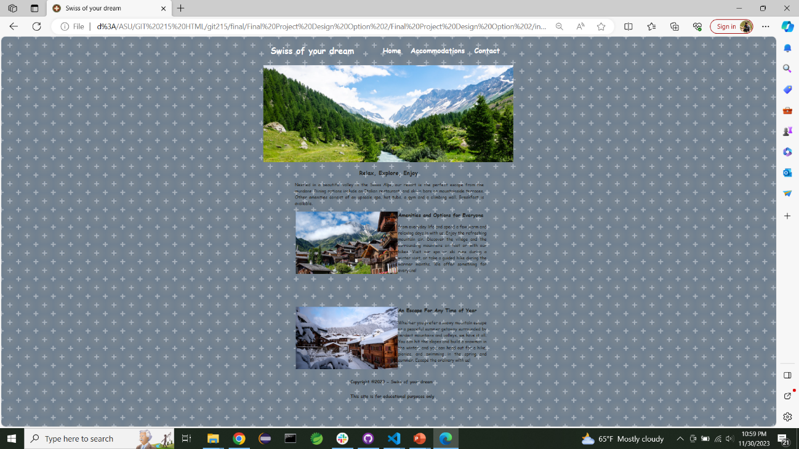Explorer

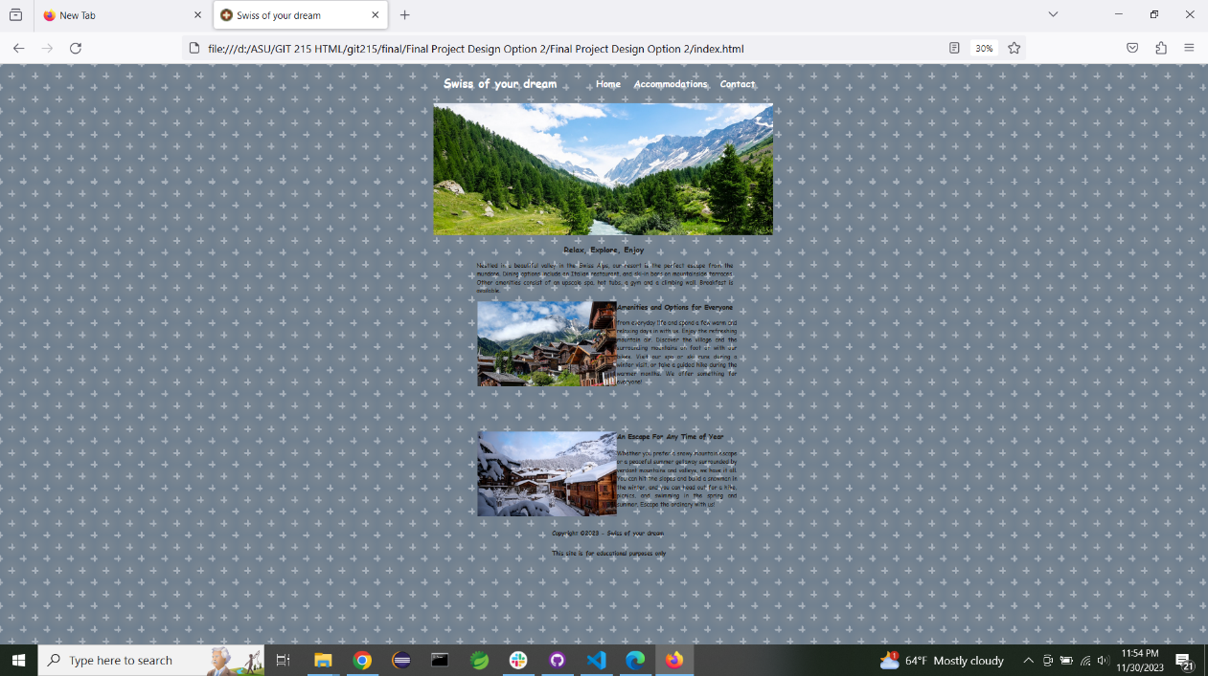Mozilla

As we can see, the difference is insignificant: the colors, the fonts are the same and the difference is only is only in the distance from the <footer> to the bottom of the screen.

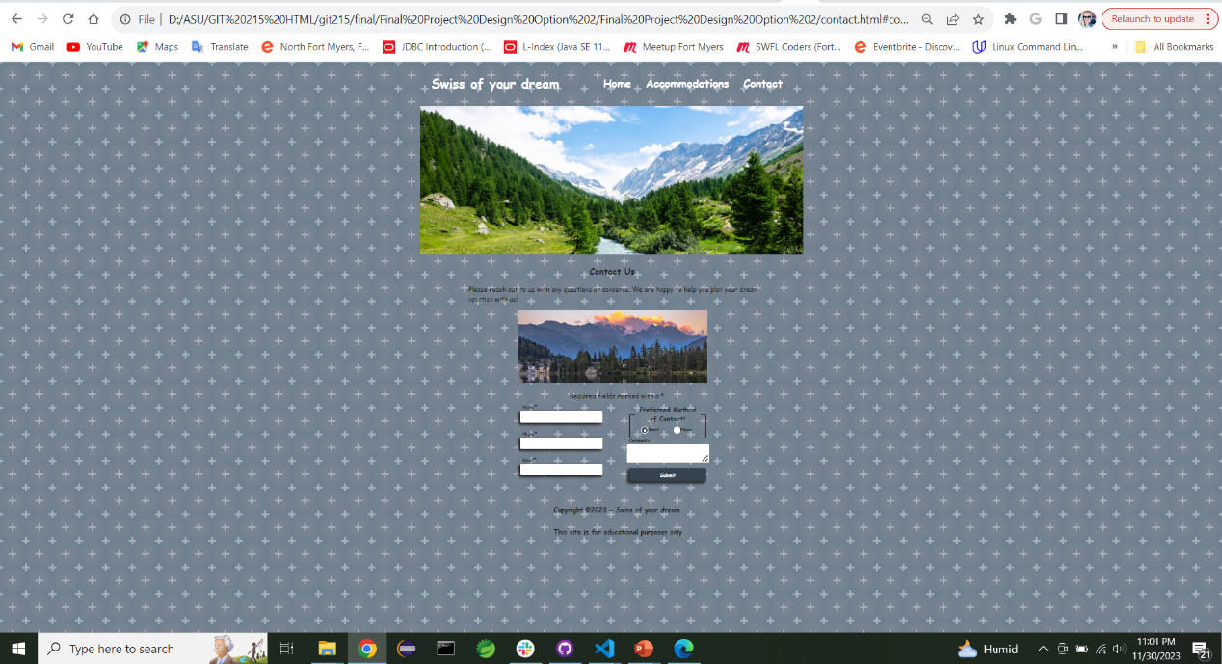Chrome

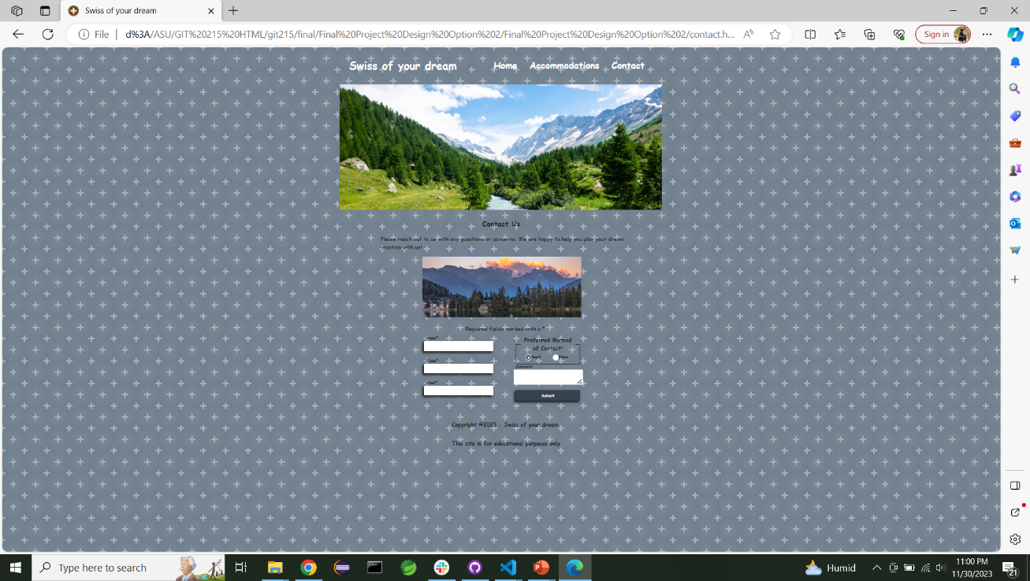Explorer

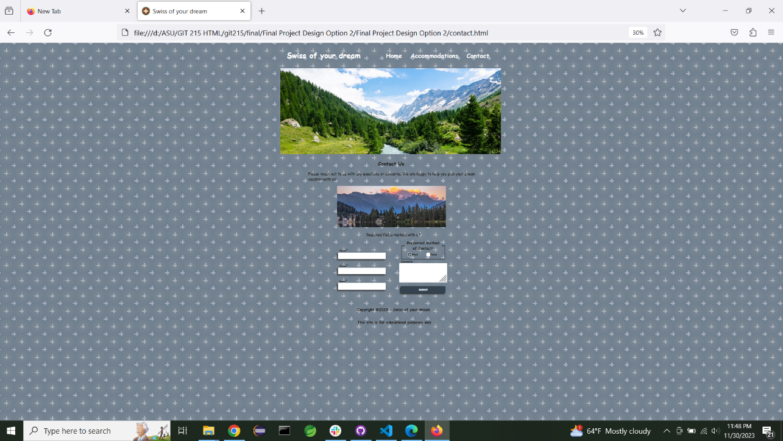Mozilla

For the page contact.html there is a significant difference in the <fieldset>. The size differs greatly in Mozilla browser. Chrome and Explorer are identical.